SESSION 20
SUBJECT: AGILE TETSING (PART 1)

Question 1: Create a table comparing Agile and Waterfall models across 5 factors relevant to software testing, such as requirements, feedback cycle, tester involvement, documentation, and flexibility.

Answer:
Objective: To understand the differences between Agile and Waterfall models based on important software testing factors.

Comparison Table: Agile vs Waterfall
Sr. No. | Factor | Agile Model | Waterfall Model
1 | Requirements | Requirements can evolve during development based on feedback. | Requirements are generally defined before development begins.
2 | Feedback Cycle | Feedback is collected frequently during sprints. | Feedback is commonly collected at defined stages or after a phase is completed.
3 | Tester Involvement | Testers participate throughout development and testing activities. | Testers are often more involved after the development phase, although earlier involvement is possible.
4 | Documentation | Documentation is maintained as needed and updated as the project evolves. | Detailed documentation is commonly prepared at each phase.
5 | Flexibility | Changes can be incorporated into upcoming sprints. | Changes to completed phases may require additional effort and formal approval.
Conclusion: Agile supports continuous testing, regular feedback, and adaptability. Waterfall follows a sequential approach with clearly defined phases and planned testing activities.

Question 2: Pick any app you use daily (like Instagram, Zomato, or Paytm) and describe how the testing process would look different if the team used Agile instead of Waterfall. Mention at least 3 specific testing activities or practices that would change.

Answer:
Selected Application: Zomato-like Food Delivery App
Objective: To explain how the testing process changes when a food delivery application uses Agile instead of Waterfall.

Testing Process in Agile vs Waterfall
In the Waterfall model, requirements and design are generally completed before development, and testing is often performed after the development phase. In Agile, development and testing take place iteratively in short sprints, allowing the team to identify defects and receive feedback earlier.

Specific Testing Activities That Would Change
Sr. No. | Testing Activity | Waterfall Approach | Agile Approach
1 | Test Case Design | Test cases are commonly designed after requirements are documented and before the planned testing phase. | Test cases are designed and refined during sprint planning and throughout development as requirements become clearer.
2 | Test Execution | Most planned functional testing is performed after development is completed. | Testers execute tests continuously as features are developed and integrated during each sprint.
3 | Bug Reporting and Fixing | Defects are often reported during the testing phase and fixed before release. | Defects are reported as soon as they are identified, discussed with developers, and prioritized for fixing within the sprint when possible.
4 | Regression Testing | Regression testing is commonly performed during designated testing phases. | Regression tests are run regularly when changes are made to ensure existing features continue to work.
5 | Feedback and Collaboration | Feedback is often provided at phase reviews or formal handovers. | Testers, developers, and the Product Owner collaborate frequently and review progress throughout the sprint.

Example: Zomato Search Restaurant Feature
In Waterfall:
- Requirements for restaurant search are documented.
- The feature is designed and developed.
- Test cases are prepared.
- Testing is performed after development.
- Defects are reported and corrected before release.
In Agile:
- The restaurant search feature is added to the product backlog.
- The team selects the feature during sprint planning.
- Testers prepare scenarios for restaurant names, locations, filters, and empty search results.
- Developers implement the feature while testers test completed portions.
- Defects are reported and fixed during the sprint where possible.
- The team reviews the feature and gathers feedback at the Sprint Review.
Conclusion: Agile enables earlier defect detection, continuous regression testing, and faster feedback compared with a traditional sequential Waterfall workflow.

Question 3: Draw a simple workflow diagram showing the main roles (such as Scrum Master, Product Owner, Development Team, Tester) and ceremonies (like Sprint Planning, Daily Standup, Sprint Review) in a SCRUM process.

Answer:

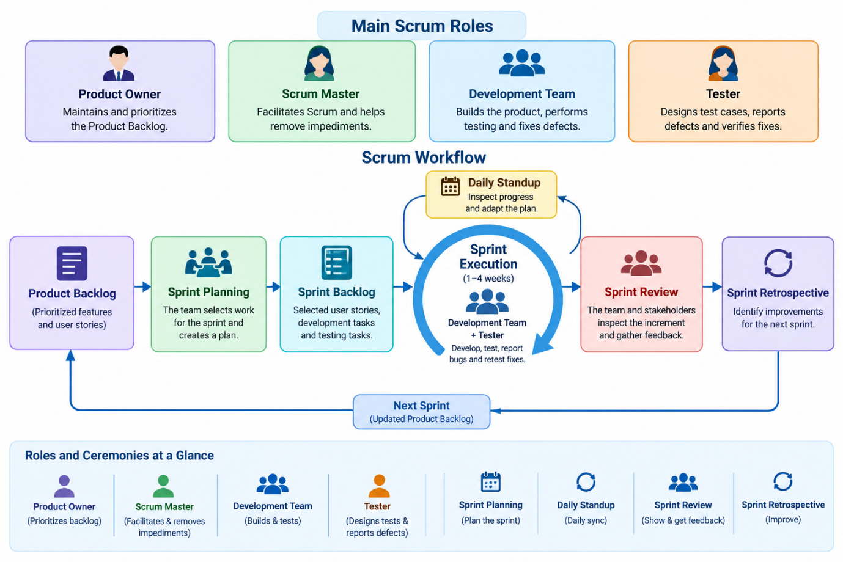
Objective: To show how the main Scrum roles and ceremonies work together during a sprint.

SCRUM Workflow Diagram
<box border radius="xl" padding={3} gap={2} align="center"> <box background="#E7F0FF" theme="light" radius="md" padding={3} width="100%" align="center"> **Product Owner**
<text size="sm" textAlign="center">Maintains and prioritizes the Product Backlog</text>
</box> <icon name="arrow-down" size="xl" /> <box border radius="md" padding={3} width="100%" align="center"> **Sprint Planning**
<text size="sm" textAlign="center">The Scrum Team selects work for the sprint and creates a plan.</text>
</box> <icon name="arrow-down" size="xl" /> <box background="#E5F6E9" theme="light" radius="md" padding={3} width="100%" align="center"> **Sprint Backlog**
<text size="sm" textAlign="center">Selected user stories, development tasks, and testing tasks</text>
</box> <icon name="arrow-down" size="xl" /> <box border radius="md" padding={3} width="100%" align="center"> **Sprint Execution**
<text size="sm" textAlign="center">Development Team and Tester develop, test, report bugs, and retest fixes.</text>
</box> <row align="center" gap={2} width="100%"> <box background="#FFF0D9" theme="light" radius="md" padding={2} flex="1" align="center"> **Daily Scrum**
<text size="xs" textAlign="center">Inspect progress and adapt the plan</text>
</box>
<box background="#F0E8FF" theme="light" radius="md" padding={2} flex="1" align="center">
**Scrum Master**

<text size="xs" textAlign="center">Facilitates Scrum and helps remove impediments</text>
</box>
</row> <icon name="arrow-down" size="xl" /> <box border radius="md" padding={3} width="100%" align="center"> **Sprint Review**
<text size="sm" textAlign="center">The team and stakeholders inspect the increment and gather feedback.</text>
</box> <icon name="arrow-down" size="xl" /> <box border radius="md" padding={3} width="100%" align="center"> **Sprint Retrospective**
<text size="sm" textAlign="center">The Scrum Team identifies improvements for the next sprint.</text>
</box> <icon name="refresh-cw" size="xl" /> <text color="secondary" size="sm" textAlign="center">The team continues with the updated Product Backlog and the next sprint.</text> </box>

Main Scrum Roles
Role | Responsibility
Product Owner | Prioritizes the Product Backlog and maximizes product value.
Scrum Master | Helps the team understand Scrum, facilitates the process, and helps remove impediments.
Development Team | In Scrum, Developers are the people in the Scrum Team who create the product increment. This includes testing and other work needed to deliver quality.
Tester | Performs testing activities, designs test cases, reports defects, and verifies fixes as part of the Developers' work.
Conclusion: Scrum promotes collaboration, regular inspection, and adaptation. Testing takes place throughout the sprint rather than being treated as a separate final phase.

Question 4: For a food delivery app (like Swiggy), map out which testing activities should happen during each phase of a typical Agile sprint (e.g., backlog grooming, sprint planning, development, review).

Answer:
Objective: To map the testing activities performed during each phase of an Agile sprint for a Swiggy-like food delivery application.

Agile Sprint Testing Activities
Sr. No. | Sprint Phase | Testing Activities | Example: Swiggy-Like App
1 | Backlog Grooming (Refinement) | Review user stories, identify acceptance criteria, identify risks, and clarify requirements. | Review the user story for applying a discount coupon and clarify coupon eligibility rules.
2 | Sprint Planning | Select user stories, estimate effort, identify testing tasks, and define the sprint goal. | Plan testing for restaurant search, adding food items to the cart, and applying a coupon.
3 | Development | Prepare test cases, review requirements with developers, test completed components, and perform unit or integration testing with the team. | Design test cases for valid coupons, expired coupons, and minimum-order requirements.
4 | Continuous Testing | Execute functional tests, integration tests, and regression tests as features become available. | Verify that applying a coupon updates the cart total correctly and does not affect delivery charges incorrectly.
5 | Bug Reporting and Fixing | Log defects, provide reproduction steps, assign priority, retest fixes, and perform regression testing. | Report a defect when a valid coupon is rejected, then retest after the developer fixes it.
6 | Sprint Review | Demonstrate completed functionality, verify acceptance criteria, and collect stakeholder feedback. | Demonstrate the food-ordering and coupon flow to the Product Owner and stakeholders.
7 | Sprint Retrospective | Discuss testing challenges, identify process improvements, and agree on actions for the next sprint. | Suggest adding automated regression checks for coupon calculations or improving test data preparation.

Example Sprint: Apply Coupon Feature
User Story: As a user, I want to apply a discount coupon to my food order so that I can receive an eligible discount.
Testing Activities:
- Backlog Grooming: Clarify coupon rules, expiry dates, minimum order value, and eligible users.
- Sprint Planning: Estimate testing effort and identify positive and negative test scenarios.
- Test Case Design: Write test cases for valid, invalid, expired, and ineligible coupons.
- Test Execution: Apply coupons and verify the discount and total amount.
- Bug Reporting: Record defects with steps to reproduce, expected results, and actual results.
- Retesting and Regression Testing: Verify fixes and confirm that the cart and checkout still work correctly.
- Sprint Review: Demonstrate the completed feature and collect feedback.
- Sprint Retrospective: Identify improvements for the next sprint.
Conclusion: Testing activities occur throughout an Agile sprint. Early requirement reviews, continuous test execution, timely bug reporting, and regular feedback help the team deliver reliable features.

